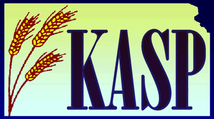
KASP FRIEND OF EDUCATION
NOMINATION FORM

The following person/group is nominated for a KASP Friend of Education Award for their work advocating for the education, rights, welfare and mental health of all children and youth at the Local, State and/or National level (please use the exact name and degrees as they should appear on the award).

In addition to this form, include three (3) letters of recommendation, a one-page description of why this/these person(s) is/are being nominated by you, and any optional supporting documentation. Incomplete packets will not be considered.

All Nominations Should be Emailed Jonathan Smeeton (jesmeeton@gmail.com)

Deadline for Submission: September 15
Winners will be announced and highlighted during the KASP Fall Convention and in the Kansas School Psychologist Newsletter.

Nominee
Title
Degree(s)
Address

Phone
E-mail
*****************************************************************************
Person making nomination
Address

Phone
E-mail

Will the above-nominated person or group be attending the NASP Annual Convention?
_______Yes ________No

________________________________
Signature of Person Nominating

